Affidavit
Date: 29 August 2025

To whom it may concern – Back a Buddy

This is to confirm that both Chief Madodhi and I are aware that Mike Tanton and Adine Hogan are trying to raise funds for our children’s school fee and feeding project which we really appreciate.

Zikomo

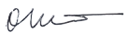
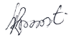
_________________________ ______________________
Chief Madodhi Robert Matewere

